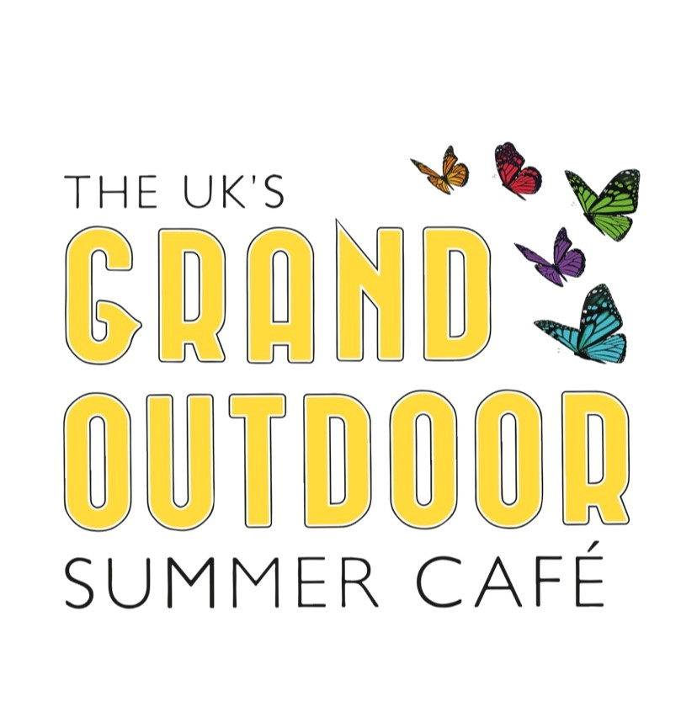
Pledge Your Support to Transform the UK’s Streets into a Grand Outdoor Summer Cafe

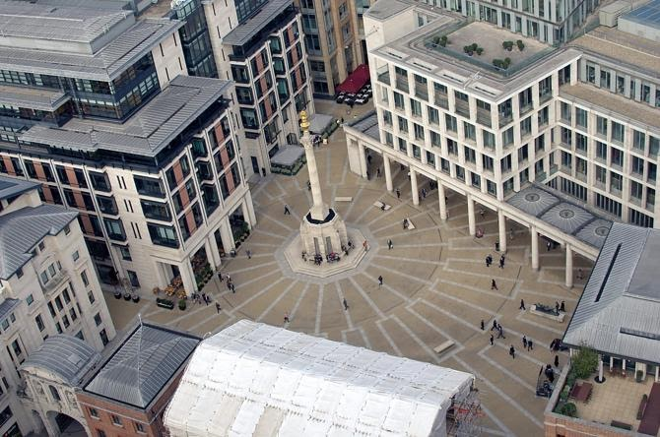

Imagine sitting outside at your favourite café, bar or restaurant, enjoying food and drinks in the sunshine this summer, all whilst physically distancing and staying safe. That dream is well on its way to becoming a reality with The UK’s Grand Outdoor Summer Café, led by The Piano Works founder Alan Lorrimer.

Following our open letter to Alok Sharma, calling on the government to allow local authorities to permit hospitality operators use open spaces and squares outside their venues to serve food and drinks, we are thrilled that Robert Jenrick, the Housing and Local Government Minister, has said “he is now considering a ‘blanket’ permission for restaurants, pubs, cafes and bars to use pedestrianised streets for tables and chairs” as reported in the Sunday Telegraph 17th May.

The #UKGrandOutDoorCafe campaign will safely restart the UK hospitality industry by transforming public spaces and streets into fabulous al fresco dining spaces whilst adhering to physical distancing. The plan also requests that strolling musicians be allowed to entertain outside guests so that the huge community of unemployed musicians have some way of recouping some of their lost earnings.

The campaign has so far been supported by industry leaders and businesses including The Piano Works, Kiln, Brat, Smoking Goat, Poppies Fish & Chips, St Austell Brewery, Oakman Inns, D&D London, Mission Mars, Corazon, The Breakfast Club, Abokado, Barburrito, Rosa’s Thai Café, Revolution Bars Group, Camm & Hooper, Kerb Food, CG Restaurants/Dirty Martini, Darwin & Wallace, Tossed, Adventure Bars, Barrio Bars, Angela Hartnett Ltd, Yummy Pubs, Prairie Fire, Thai Square, Remarkable Pubs, Lucky Voice, Aspirational Pub Company, Livelyhood Pubs, Wafflemeister, Chapel Nightclub, Hippodrome Casino, Angus Steak House/Steak & Co. and many more.

Now that the first phase of the campaign has succeeded, we are calling on you, our customers, to pledge your support. Experiences like pubs, craft beer bars, street food stalls, live music venues, food halls and high-end restaurants have been a part of this country’s identity for locals and visitors alike. Slowly and safely allowing us all to enjoy this summer is an essential step in the right direction. By showing your support, you will play a huge role in breathing life back into our hospitality industry and saying thank you to our heroes.
Pledge your support here: https://www.ukgsoc.org/.

Another key focus of the campaign is on fundraising for food and drink vouchers so that our frontline heroes can enjoy complimentary, well-earned moments at the UKGSOC. We’re aiming to raise £70,000 to show our appreciation to those amazing key workers who have been keeping us safe during the pandemic. Donations can be made via: https://www.justgiving.com/crowdfunding/ukgrandsummeroutdoorcafe.

Alan Lorrimer says: “We have two formerly successful 400 capacity late night, non–stop, audience requested, live music venues The Piano Works in Farringdon and the West End, and at present we are totally dependent on the Govt. for our survival. They’ve done an amazing job of furloughing our 130 staff, removing rates for a year, delaying VAT payments, and guaranteeing a business loan. Our landlords and suppliers have been hugely supportive as have our bankers Santander. Without their faith, help and goodwill we would not be here ready to re-open. But how do we pay them back?

This initiative aims to safely get people back onto our streets and revitalize our villages, towns and city centres. With the Government’s continued help we can thank the British public for behaving so responsibly and reward our frontline, dining and drinking outside across the UK enjoying the great British Summer”

The government has announced that July is a best-case scenario for restaurants, cafes and bars to reopen albeit with physical distancing, but many of our favourite places to go out and meet friends will struggle to survive with reduced seating, and others may not be able to survive at all. The Grand Summer Outdoor Café is an excellent opportunity to revive the UK’s beloved hospitality industry and bring back some normalcy into our everyday lives. The hugely responsible British public deserve a massive thank you.

To support the campaign, visit www.UKGSOC.org to support our frontline heroes and sign up to make a positive change.

http://pianoworks.bar
FB: @thepianoworksfarringdon | T: @ thepianoworksWE| I: @thepianoworks
#UKGrandOutdoorCafe

For media enquiries, please contact:

Emma Hawley, Cru Communications
M: 07516762597
E: emma@cru-comms.com

Colleen Monaghan, Cru Communications
M: 07568586060
E: colleen@cru-comms.com

